

**Design Specifications**

**RCG|enable Banking**

*May 2017*

Revision History

|  |  |  |  |
| --- | --- | --- | --- |
| Revision | Author(s) | Date | Description |
| 1.0 | A. Veluz | 03/21/2017 | Initial draft |
| 1.1 | A. Veluz | 05/08/2017 | Added services |
| 1.2 | A. Veluz | 05/09/2017 | Added UI Interaction |
| 1.3 | A. Veluz | 05/10/2017 | Removed clients table and all references to it |
| 1.4 | A. Veluz | 05/24/2017 | Added the txn_date to the src_transactions table |

Table of Contents

User Interface 4

Design Overview 4

General Controls and Information 4

Navigation 4

Tab Navigation 5

“Before” Counts 6

Party Resolution “Before” Grid 7

Party Resolution “Post” Grid 8

“Post” Counts 10

Pattern Analysis Transactions “Post” Grid 11

Solution ROI tab 12

UI Screen Order 13

UI Interaction and Data Services 32

Use Case Tab 32

Party Resolution Tab 33

Event Management Tab 35

Pattern Analysis Tab 37

Solution ROI Tab 38

Database 39

Database Design Concept 39

Source tables 39

src_accounts 39

src_party 41

src_transactions 42

src_alerts 43

src_cases 43

Post tables 44

post_PR_party 44

post_PR_accounts 45

post_PR_consolidation 45

post_PR_address 46

post_PR_phone 46

post_PR_email 46

post_PR_contact 47

post_EM_transactions 47

post_EM_alerts 48

post_EM_cases 49

post_PA_alerts 50

post_PA_cases 51

Reference tables 52

clients 52

educ_institutions 52

suspicious_accounts 53

# User Interface

## Design Overview

The lay-out and the flow of the demo site is in the Powerpoint presentation attached.



## General Controls and Information

### Navigation

The demo page will act as a combination of a presentation and as an application. Similar to a presentation, a forward and back action button will be available on screen so that the presenter can navigate through the demo story. The image below shows where the buttons will appear on the lower right side of the screen.

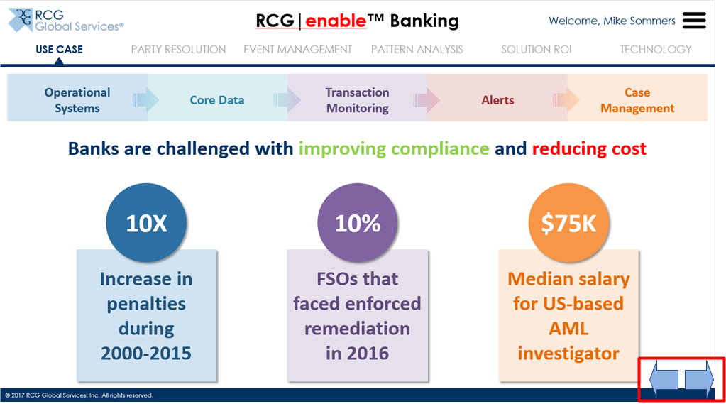

The flow and order in which the information appears is outlined in the Powerpoint presentation.

### Tab Navigation

When navigating the demo site, the presenter can use the Forward and Back buttons to navigate within the tab. In order to move on to the next tab, the presenter will need to click on the tab itself.

The demo site will have 6 tabs – Use Case, Party Resolution, Event Management, Pattern Analysis, Solution ROI and Technology.

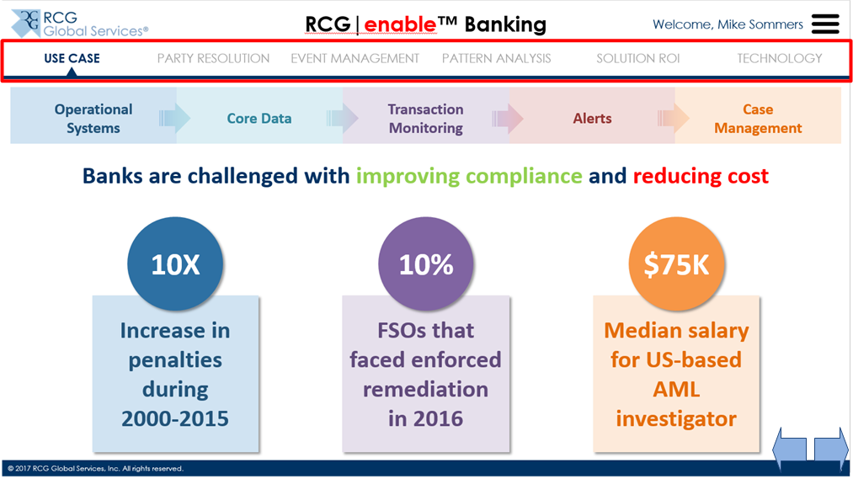

If the presenter clicks on the tab, it advances the story to the start of the tab.

### “Before” Counts

Starting in Slide 2, a set of numbers are indicated showing the “Before” counts. These counts are meant to show the existing counts from a client’s application.

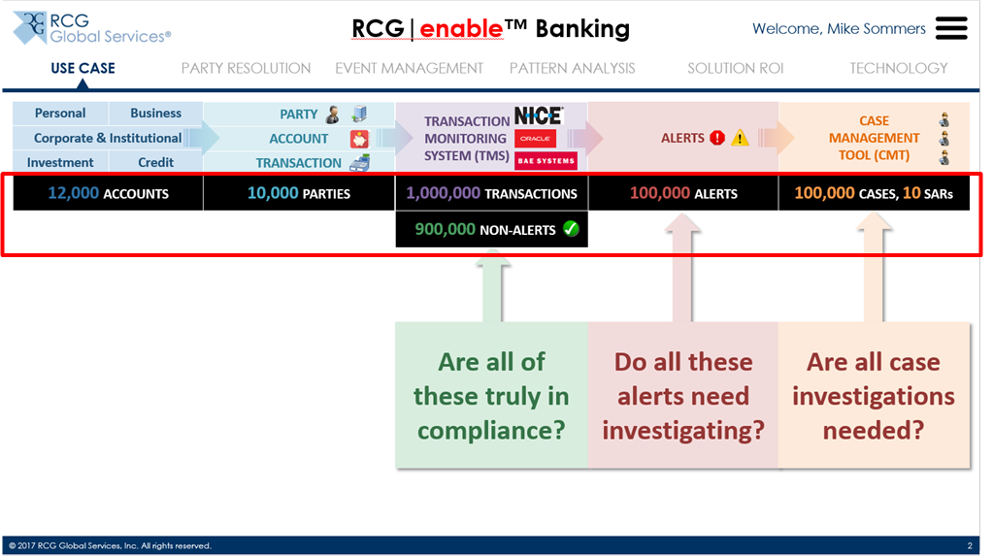

These numbers will be retrieved from the Database via JQueries

* Accounts will be the number of records in the src_accounts table
* Parties will be the number of distinct records in the src_party table
* Transactions will be the number of records in the src_transactions table
* Alerts will be the number of records in the src_alerts table
* Non-Alerts will be calculated as the difference between the Transactions and Alerts
* Cases will be the number of records in the src_cases table
* SARs will be the number of records in the src_cases table where the sar_id is not NULL

### Party Resolution “Before” Grid

Starting in Slide 3, there are a number of grids that appear. The first of which is the Party Resolution “Before” grid. This grid aims to show how the existing client systems consolidate their accounts into parties. The information here will be retrieved from the Source tables.

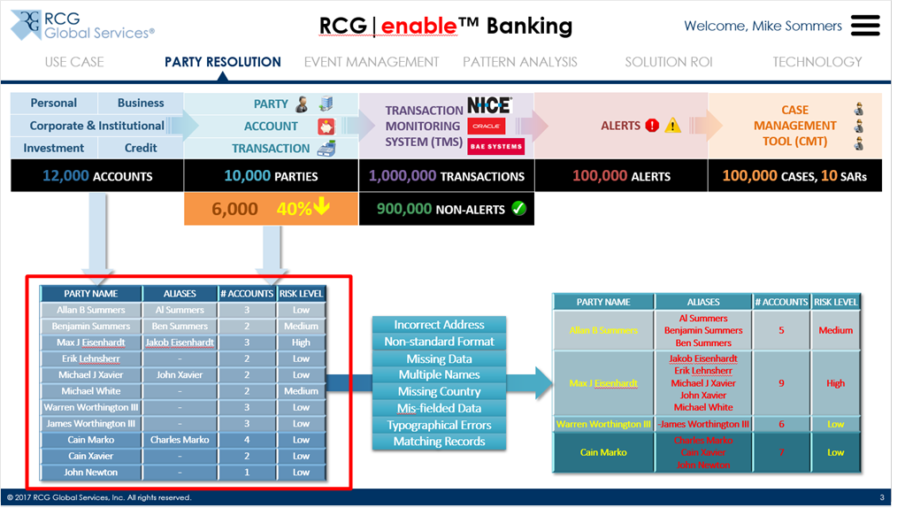

The Party Name, Aliases and Risk Level will come from joining the src_party table while the # Accounts will be the count of entries in the src_accounts table for the party_id. The Risk Level is calculated based on the party_risk_score (Low <= 60; Medium 61-80; High > 80).

The entries that will be shown in the UI are only the entries in the src_party where the visible field is set to TRUE.

The Party Name will be a hyperlink and will display the Party and Account information from the src_accounts and src_party in a modal window. The presenter may opt not to show this during the demo. <UI Design to follow but will have the same look-and-feel as what is in the current Banking demo for Accounts>

### Party Resolution “Post” Grid

The Party Resolution “Post” grid is on Slide 3 and this aims to show how the RCG solution will be able to effectively reduce the amount of parties using a combination of various consolidation techniques.

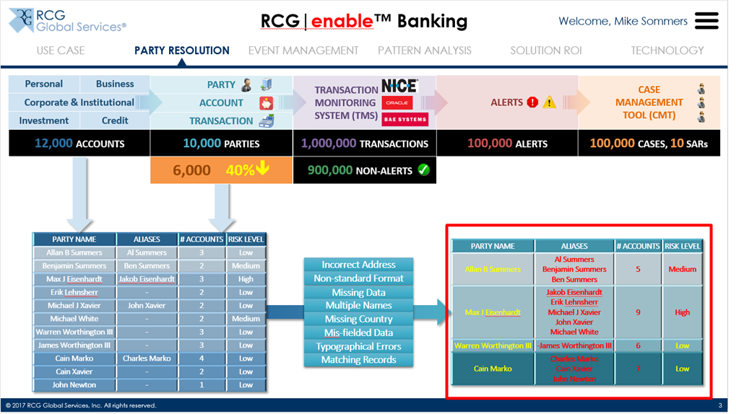

The Party Name, Aliases and Risk Level will come from post_party while the # Accounts will be the count of entries in the post_party_accounts table for the party_id. The Risk Level is calculated based on the party_risk_score (Low <= 60; Medium 61-80; High > 80).

The entries that will be shown in the UI are only the entries in the post_party where the visible field is set to TRUE.

The Party Name will be a hyperlink and will display how the data was consolidated. This will be a modal window as shown in Slide 4.

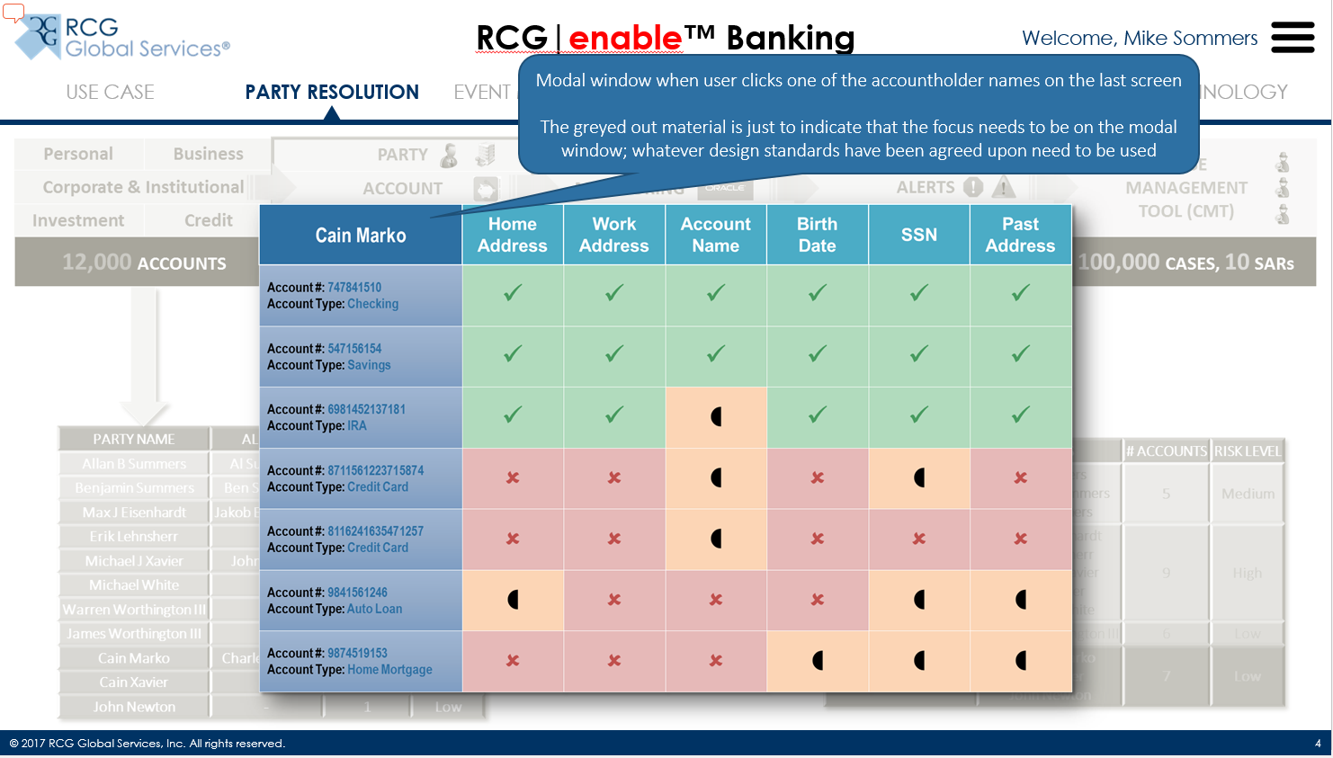

This will show if it is a Full Match, Partial Match or No Match.

<Need to put information on how the consolidation will work - <https://dcsdemo.nl/>>

### “Post” Counts

The “Post” counts aim to show how the RCG solution will change the different metrics.

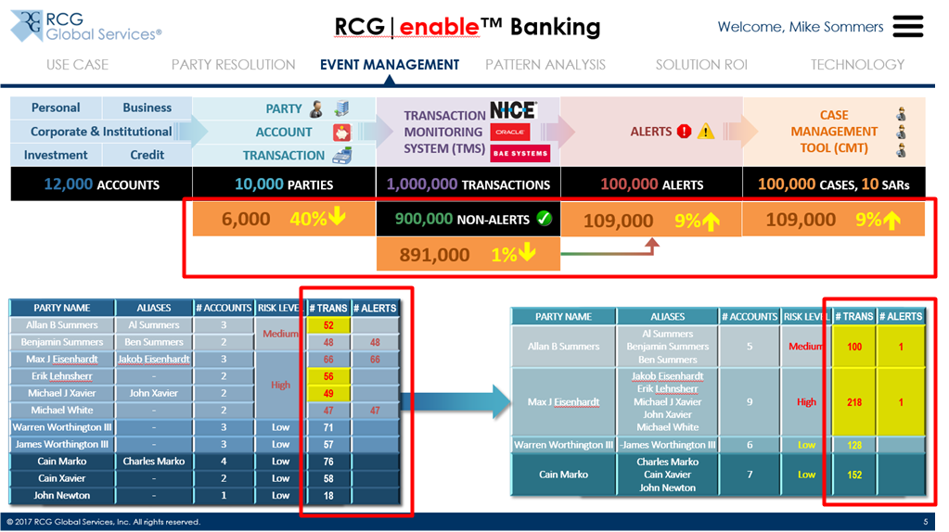

The numbers in the middle portion will be retrieved from the Database via JQueries

* Parties will be the number of distinct records in the post_party table
* Alerts will be the number of records in the post_alerts table
* Non-Alerts will be calculated as the difference between the Transactions and Alerts
* Cases will be the number of records in the post_cases table
* SARs will be the number of records in the post_cases table where the sar_id is not NULL

The numbers in the left grid represents what the client currently has and will be retrieved from the src_party, src_transactions and src_alerts tables.

The numbers in the right grid will be retrieved from the post_party, post_party_transactions and post_alerts tables.

### Pattern Analysis Transactions “Post” Grid

The Transactions grid in Slide 6 aims to show how the transactions are grouped together and to show how they are classified as Benign or Suspicious.

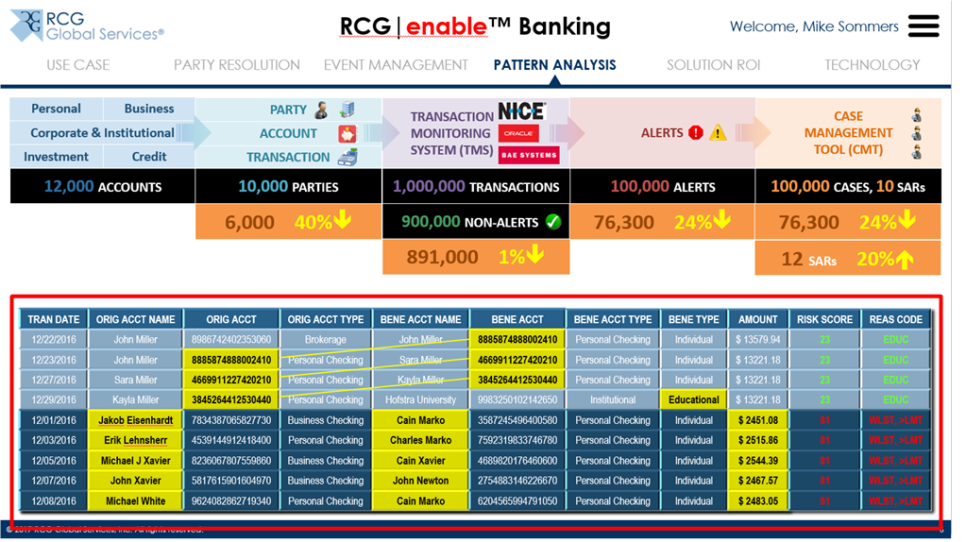

The Transactions grid will be retrieved from the post_party_transactions and src_transactions tables. In order to have more focus on the flow, the page will simply have the grid and when an entry in the grid is selected, a modal window is launched that shows how the accounts are related. The Risk Score and Reason Codes are displayed as the presenter goes to through the modal information.

### Solution ROI tab

The Solution ROI tab in Slide 7 aims to be an interactive tab where the presenter can plug in the values and show the ROI for the RCG solution.

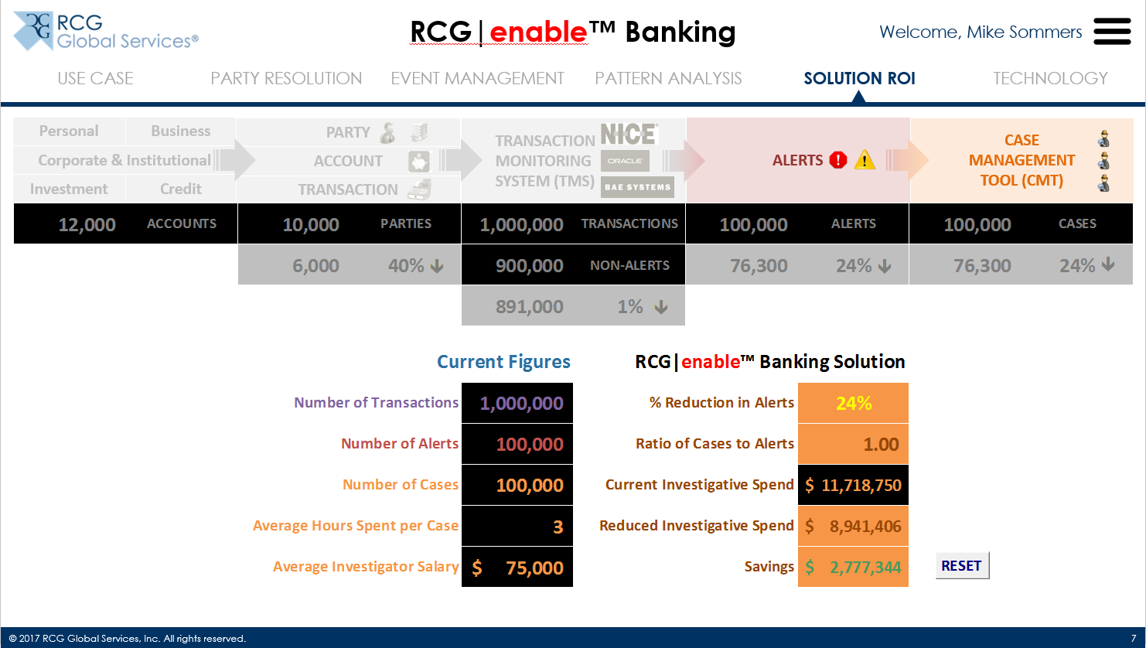

The attached Excel spreadsheet contains the calculations.



## UI Screen Order

|  |  |
| --- | --- |
| **UI Order** | **Screen** |
| 1 |  |
| 2 |  |
| 3 |  |
| 4 |  |
| 5 |  |
| 6 |  |
| 7 |  |
| 8 |  |
| 9 |  |
| 10 |  |
| 11 |  |
| 12 |  |
| 13 |  |
| 14 |  |
| 15 |  |
| 16 |  |
| 17 |  |
| 18 |  |
| 19 |  |
| 20 |  |
| 21 |  |
| 22 |  |
| 23 |  |
| 24 |  |
| 25 |  |
| 26 |  |
| 27 |  |
| 28 |  |
| 29 |  |
| 30 |  |
| 31 |  |
| 32 |  |
| 33 |  |
| 34 |  |
| 35 |  |
| 36 |  |
| 37 |  |
| 38 |  |

# UI Interaction and Data Services

## Use Case Tab

| **UI Action**  **(UI Order) Action**  **Data Service** | **UI Data Elements Provided** | **Data Service Data Elements Provided** |
| --- | --- | --- |
| (1) Open demo | -- | -- |
| (2) Go to Use Case tab | -- | -- |
| (3) Click Next/Proceed | -- | -- |
| (4) Click Next/Proceed | -- | -- |
| (5) Click Next/Proceed | -- | -- |
| (6) Click Next/Proceed | -- | -- |
| (7) Click Next/Proceed | -- | -- |
| (8) Click Next/Proceed  **getCountSrcAccounts** | -- | * Count |
| (9) Click Next/Proceed  **getCountSrcParty** | -- | * Count |
| (10) Click Next/Proceed  **getCountSrcTransactions** | -- | * Count |
| (11) Click Next/Proceed  Calculate **(getCountSrcTransactions** – **getCountSrcAlerts)**  **getCountSrcAlerts** | -- | * Count |
| (12) Click Next/Proceed  **getCountSrcCases**  **getCountSrcSar** | -- | * Count |
| (13) Click Next/Proceed | -- | -- |
| (14) Click Next/Proceed | -- | -- |
| (15) Click Next/Proceed | -- | -- |

## Party Resolution Tab

| **UI Action**  **(UI Order) Action**  **Data Service** | **UI Data Elements Provided** | **Data Service Data Elements Provided** |
| --- | --- | --- |
| (16) Click Next/Proceed or go to Party Resolution tab  **getSummarySrc** | * visible = 1 | * party_id (src_party) * party_name (src_party) * party_alias (src_party) * count_accounts   + count of accounts associated with the party (src_party joined with src_accounts on party_id) * risk_score (get the highest value for the party_risk_score and the account_risk score) * risk_level   + If risk_score <= 60, set to Low   + If risk_score > 60 and <= 80, set to Medium   + If risk_score > 80, set to High * count_transactions   + count of transactions associated with the party (src_accounts joined with src_transactions on acct_number = src_acct_number and acct_number = rcpt_acct_number) * count_alerts   + count of alerts associated with the party (src_party joined with src_alerts on party_id) * count_cases   + count of cases associated with the party (src_alerts joined with src_cases on case_id) * count_sar   + distinct count of sar_id associated with the party (src_alerts joined with src_cases on case_id where sar_id is not empty/NULL) |
| (17) Click Next/Proceed  **getSummaryPostEM** | * visible = 1 | * party_id (post_PR_party) * party_name (post_PR_party) * party_alias (post_PR_party) * count_accounts   + count of accounts associated with the party (post_PR_party joined with post_PR_accounts on party_id) * party_risk_score (post_PR_party) * risk_level   + If party_risk_score <= 60, set to Low   + If party_risk_score > 60 and <= 80, set to Medium   + If party_risk_score > 80, set to High * count_transactions   + count of transactions associated with the party (post_PR_party joined with post_EM_transactions on party_id) * count_alerts   + count of alerts associated with the party (post_PR_party joined with post_EM_alerts on party_id) * count_cases   + count of cases associated with the party (post_EM_alerts joined with post_EM_cases on party_id) * count_sar   + distinct count of sar_id associated with the party (post_EM_alerts joined with post_EM_cases on case_id where sar_id is not empty/NULL) |
| (18) Click Next/Proceed | -- | -- |
| (19) Click Next/Proceed  **getCountPostParty**  Calculate Percentage  **(getCountPostParty / getCountSrcParty)** | -- | * Count |
| (20) Click on a Party Name from the list on the right to show modal window  **getConsolidationPostPR** | * Party_id = Selected Party_id | * account_number   + post_PR_Party joined with post_PR_accounts on party_id; post_PR_accounts joined with src_accounts on acct_id * account_type   + post_PR_Party joined with post_PR_accounts on party_id; post_PR_accounts joined with src_accounts on acct_id * All attribute names, values and details from the post_PR_consolidation table   + post_PR_accounts joined with post_PR_consolidation on acct_id |

## Event Management Tab

| **UI Action**  **(UI Order) Action**  **Data Service** | **UI Data Elements Provided** | **Data Service Data Elements Provided** |
| --- | --- | --- |
| (21) Close modal window from (20) and click Next/Proceed or go to Event Management tab  **getSummarySrc** | * visible = 1 | * party_id (src_party) * party_name (src_party) * party_alias (src_party) * count_accounts   + count of accounts associated with the party (src_party joined with src_accounts on party_id) * risk_score (get the highest value for the party_risk_score and the account_risk score) * risk_level   + If risk_score <= 60, set to Low   + If risk_score > 60 and <= 80, set to Medium   + If risk_score > 80, set to High * count_transactions   + count of transactions associated with the party (src_accounts joined with src_transactions on acct_number = src_acct_number and acct_number = rcpt_acct_number) * count_alerts   + count of alerts associated with the party (src_party joined with src_alerts on party_id) * count_cases   + count of cases associated with the party (src_alerts joined with src_cases on case_id) * count_sar * distinct count of sar_id associated with the party (src_alerts joined with src_cases on case_id where sar_id is not empty/NULL) |
| (22) Click Next/Proceed | -- | -- |
| (23) Click Next/Proceed  **getSummaryPostEM** | * visible = 1 | * party_id (post_PR_party) * party_name (post_PR_party) * party_alias (post_PR_party) * count_accounts   + count of accounts associated with the party (post_PR_party joined with post_PR_accounts on party_id) * party_risk_score (post_PR_party) * risk_level   + If party_risk_score <= 60, set to Low   + If party_risk_score > 60 and <= 80, set to Medium   + If party_risk_score > 80, set to High * count_transactions   + count of transactions associated with the party (post_PR_party joined with post_EM_transactions on party_id) * count_alerts   + count of alerts associated with the party (post_PR_party joined with post_EM_alerts on party_id) * count_cases   + count of cases associated with the party (post_EM_alerts joined with post_EM_cases on party_id) * count_sar   + distinct count of sar_id associated with the party (post_EM_alerts joined with post_EM_cases on case_id where sar_id is not empty/NULL) |
| (24) Click Next/Proceed  Calculate **(getCountSrcTransactions** – **getCountPostEMAlerts)**  Calculate the percentage  **(getCountPostEMAlerts - getCountSrcAlerts) /**  **(getCountSrcTransactions** – **getCountSrcAlerts)** | -- | * Count |
| (25) Click Next/Proceed  Calculate **getCountPostEMAlerts**  Calculate the percentage  **(getCountPostEMAlerts - getCountSrcAlerts) /**  **getCountSrcAlerts** | -- | * Count |
| (26) Click Next/Proceed  Calculate **getCountPostEMCases**  Calculate the percentage  **(getCountPostEMCases - getCountSrcCases) /**  **getCountSrcCases** | -- | * Count |

## Pattern Analysis Tab

| **UI Action**  **(UI Order) Action**  **Data Service** | **UI Data Elements Provided** | **Data Service Data Elements Provided** |
| --- | --- | --- |
| (27) Click Next/Proceed or go to Pattern Analysis tab | -- | -- |
| (28) Click Next/Proceed  **getTransactionsPostEMPA** | * visible = 1 | * All transaction information in post_EM_transactions table where visible = 1   + include the post_txn_attributes since that will contain the Bene Type, Risk Score and Reas Code that will be displayed in the UI   + All transaction information in src_transactions table (post_EM_transactions table joined with src_transactions table on txn_id)   + All related account information like account_name, account_type (post_PR_Party joined with post_PR_accounts on party_id; post_PR_accounts joined with src_accounts on acct_id) |
| (29) Click Next/Proceed  There is no data service to call as UI is highlighting the story. | -- | -- |
| (30) Click Next/Proceed  There is no data service to call as UI is highlighting the story. | -- | -- |
| (31) Click Next/Proceed  There is no data service to call as UI is highlighting the story. | -- | -- |
| (32) Click Next/Proceed  **getTransactionsPostEMPA** | * visible = 1 | * All transaction information in post_EM_transactions table where visible = 1   + include the post_txn_attributes since that will contain the Bene Type, Risk Score and Reas Code that will be displayed in the UI   + All transaction information in src_transactions table (post_EM_transactions table joined with src_transactions table on txn_id)   + All related account information like account_name, account_type (post_PR_Party joined with post_PR_accounts on party_id; post_PR_accounts joined with src_accounts on acct_id) |
| (33) Click Next/Proceed  There is no data service to call as UI is highlighting the story. | -- | -- |
| (34) Click Next/Proceed  **getTransactionsPostEMPA** | * visible = 1 | * All transaction information in post_EM_transactions table where visible = 1   + include the post_txn_attributes since that will contain the Bene Type, Risk Score and Reas Code that will be displayed in the UI   + All transaction information in src_transactions table (post_EM_transactions table joined with src_transactions table on txn_id)   + All related account information like account_name, account_type (post_PR_Party joined with post_PR_accounts on party_id; post_PR_accounts joined with src_accounts on acct_id) |
| (35) Click Next/Proceed  Calculate **getCountPostPAAlerts**  Calculate the percentage  **(getCountPostPAAlerts - getCountSrcAlerts) /**  **getCountSrcAlerts** | -- | * Count |
| (36) Click Next/Proceed  Calculate **getCountPostPACases**  Calculate the percentage  **(getCountPostPACases - getCountSrcCases) /**  **getCountSrcCases** | -- | * Count |
| (37) Click Next/Proceed  Calculate **getCountPostPASar**  Calculate the percentage  **(getCountPostPASae - getCountSrcSar) /**  **getCountSrcSar** | -- | * Count |

## Solution ROI Tab

| **UI Action**  **(UI Order) Action**  **Data Service** | **UI Data Elements Provided** | **Data Service Data Elements Provided** |
| --- | --- | --- |
| (38) Click Next/Proceed or go to Solution ROI tab  The calculation logic is in the **Solution ROI tab section** of the document. | -- | -- |

# Database

## Database Design Concept

The design is split into 3 groups:

* Source tables
* Post tables
* Reference tables

## Source tables

The Source tables are to contain the data from the client systems. The concept is to import the data from the clients into these tables and this will be used for the “Before” picture. The Source tables are as follows:

* src_accounts
* src_party
* src_transactions
* src_alerts
* src_cases

### src_accounts

This contains all the account information from the client systems. This will have the account details, account holder information, account holder address and contact information.

| **Column Name** | **Data Type** | **Key-Required-Optional** | **Primary Table** | **Description** |
| --- | --- | --- | --- | --- |
| acct_id | int | PK |  | This is the primary key for the table |
| party_id | int | Optional | src_party | This is to link the account to the party information |
| visible | bit | Required |  | This is to indicate if the entry will be visible in the UI or not |
| acct_number | varchar(20) | Required |  | This is the account number |
| acct_type | varchar(20) | Optional |  | This is the account type and can have a value of Savings, Checking, IRA, etc. |
| acct_risk_score | int | Optional |  | This is the risk score associated with the account |
| ah_name | varchar(50) | Required |  | This is the account holder name |
| ah_type | varchar(20) | Optional |  | This is the account holder type and can have a value of Individual or Institution |
| ah_first_name | varchar(20) | Optional |  | This is the account holder first name |
| ah_mid_name | varchar(20) | Optional |  | This is the account holder middle name |
| ah_last_name | varchar(20) | Optional |  | This is the account holder last name |
| ah_suffix | varchar(20) | Optional |  | This is the account holder suffix |
| ah_alias | varchar(40) | Optional |  | This is the account holder alias |
| ah_ssn | varchar(9) | Optional |  | This is the account holder SSN |
| ah_dob | date | Optional |  | This is the account holder Date of Birth |
| home_addr_line_1 | varchar(50) | Optional |  | This is the account holder Home Address Line 1 |
| home_addr_line_2 | varchar(50) | Optional |  | This is the account holder Home Address Line 2 |
| home_addr_line_3 | varchar(50) | Optional |  | This is the account holder Home Address Line 3 |
| home_addr_county | varchar(20) | Optional |  | This is the account holder Home Address County |
| home_addr_city | varchar(20) | Optional |  | This is the account holder Home Address City |
| home_addr_postal_zip | varchar(10) | Optional |  | This is the account holder Home Address Postal / Zip Code |
| home_addr_state_province | varchar(20) | Optional |  | This is the account holder Home Address State / Province |
| home_addr_country | varchar(20) | Optional |  | This is the account holder Home Address Country |
| work_addr_line_1 | varchar(50) | Optional |  | This is the account holder Work Address Line 1 |
| work_addr_line_2 | varchar(50) | Optional |  | This is the account holder Work Address Line 2 |
| work_addr_line_3 | varchar(50) | Optional |  | This is the account holder Work Address Line 3 |
| work_addr_county | varchar(20) | Optional |  | This is the account holder Work Address County |
| work_addr_city | varchar(20) | Optional |  | This is the account holder Work Address City |
| work_addr_postal_zip | varchar(10) | Optional |  | This is the account holder Work Address Postal / Zip Code |
| work_addr_state_province | varchar(20) | Optional |  | This is the account holder Work Address State / Province |
| work_addr_country | varchar(20) | Optional |  | This is the account holder Work Address Country |
| primary_phone_number | varchar(15) | Optional |  | This is the account holder Primary Phone Number |
| primary_phone_type | varchar(15) | Optional |  | This is the account holder Primary Phone Type - Celphone, Landline, etc. |
| secondary_phone_number | varchar(15) | Optional |  | This is the account holder Secondary Phone Number |
| secondary_phone_type | varchar(15) | Optional |  | This is the account holder Secondary Phone Type - Celphone, Landline, etc. |
| primary_email_addr | varchar(30) | Optional |  | This is the account holder Primary email address |
| secondary_email_addr | varchar(30) | Optional |  | This is the account holder Secondary email address |

### src_party

This contains the party information from the client systems. The idea here is that the client already consolidated the accounts into parties and this has the relevant party information.

| **Column Name** | **Data Type** | **Key-Required-Optional** | **Primary Table** | **Description** |
| --- | --- | --- | --- | --- |
| party_id | int | PK |  | This is the primary key for the table |
| visible | bit | Required |  | This is to indicate if the entry will be visible in the UI or not |
| party_name | varchar(50) | Required |  | This is the party name |
| party_risk_score | int | Optional |  | This is the risk score associated with the party |
| party_type | varchar(20) | Optional |  | This is the party type and can have a value of Individual or Institution |
| party_first_name | varchar(20) | Optional |  | This is the party first name |
| party_mid_name | varchar(20) | Optional |  | This is the party middle name |
| party_last_name | varchar(20) | Optional |  | This is the party last name |
| party_suffix | varchar(20) | Optional |  | This is the party suffix |
| party_alias | varchar(40) | Optional |  | This is the party alias |
| party_ssn | varchar(9) | Optional |  | This is the party SSN |
| party_dob | date | Optional |  | This is the party Date of Birth |
| home_addr_line_1 | varchar(50) | Optional |  | This is the party Home Address Line 1 |
| home_addr_line_2 | varchar(50) | Optional |  | This is the party Home Address Line 2 |
| home_addr_line_3 | varchar(50) | Optional |  | This is the party Home Address Line 3 |
| home_addr_county | varchar(20) | Optional |  | This is the party Home Address County |
| home_addr_city | varchar(20) | Optional |  | This is the party Home Address City |
| home_addr_postal_zip | varchar(10) | Optional |  | This is the party Home Address Postal / Zip Code |
| home_addr_state_province | varchar(20) | Optional |  | This is the party Home Address State / Province |
| home_addr_country | varchar(20) | Optional |  | This is the party Home Address Country |
| work_addr_line_1 | varchar(50) | Optional |  | This is the party Work Address Line 1 |
| work_addr_line_2 | varchar(50) | Optional |  | This is the party Work Address Line 2 |
| work_addr_line_3 | varchar(50) | Optional |  | This is the party Work Address Line 3 |
| work_addr_county | varchar(20) | Optional |  | This is the party Work Address County |
| work_addr_city | varchar(20) | Optional |  | This is the party Work Address City |
| work_addr_postal_zip | varchar(10) | Optional |  | This is the party Work Address Postal / Zip Code |
| work_addr_state_province | varchar(20) | Optional |  | This is the party Work Address State / Province |
| work_addr_country | varchar(20) | Optional |  | This is the party Work Address Country |
| primary_phone_number | varchar(15) | Optional |  | This is the party Primary Phone Number |
| primary_phone_type | varchar(15) | Optional |  | This is the party Primary Phone Type - Celphone, Landline, etc. |
| secondary_phone_number | varchar(15) | Optional |  | This is the party Secondary Phone Number |
| secondary_phone_type | varchar(15) | Optional |  | This is the party Secondary Phone Type - Celphone, Landline, etc. |
| primary_email_addr | varchar(30) | Optional |  | This is the party Primary email address |
| secondary_email_addr | varchar(30) | Optional |  | This is the party Secondary email address |

### src_transactions

This contains the transactions information from the client systems. There are 5 added attribute values in the table so that if there are relevant information needed, they can just be added as an attribute.

| **Column Name** | **Data Type** | **Key-Required-Optional** | **Primary Table** | **Description** |
| --- | --- | --- | --- | --- |
| txn_id | int | PK |  | This is the primary key for the table |
| visible | bit | Required |  | This is to indicate if the entry will be visible in the UI or not |
| txn_key | varchar(50) | Required |  | This is the transaction key and is the key generated by the client system |
| txn_date | Date/time | Required |  | This is the transaction date |
| txn_type | varchar(20) | Required |  | This is the transaction type and can have a value of Withdrawal, Deposit, Payments, etc. |
| txn_amount | numeric(10,2) | Required |  | This is the transaction amount. The amount can be a positive (Deposit) or negative (Withdrawal and Paments) value |
| src_acct_number | varchar(20) | Required |  | This is the source account number. For cash deposits, this will be set to CASH. |
| rcpt_acct_number | varchar(20) | Required |  | This is the recipient account number. For cash withdrawals, this will be set to CASH. |
| attr_1_name | varchar(20) | Optional |  | This is an additional attribute |
| attr_1_value | varchar(20) | Optional |  | This is an additional attribute |
| attr_2_name | varchar(20) | Optional |  | This is an additional attribute |
| attr_2_value | varchar(20) | Optional |  | This is an additional attribute |
| attr_3_name | varchar(20) | Optional |  | This is an additional attribute |
| attr_3_value | varchar(20) | Optional |  | This is an additional attribute |
| attr_4_name | varchar(20) | Optional |  | This is an additional attribute |
| attr_4_value | varchar(20) | Optional |  | This is an additional attribute |
| attr_5_name | varchar(20) | Optional |  | This is an additional attribute |
| attr_5_value | varchar(20) | Optional |  | This is an additional attribute |

### src_alerts

This contains the alert information from the client systems. There are 5 added attribute values in the table so that if there are relevant information needed, they can just be added as an attribute.

| **Column Name** | **Data Type** | **Key-Required-Optional** | **Primary Table** | **Description** |
| --- | --- | --- | --- | --- |
| alert_id | int | PK |  | This is the primary key for the table |
| visible | bit | Required |  | This is to indicate if the entry will be visible in the UI or not |
| party_id | int | Required | src_party | This is the link to the party id |
| txn_id | varchar(50) | Required | src_transactions | This is the link to the transaction id |
| case_id | int | Optional | src_cases | This is the link to the cases |
| rule_violated | varchar(50) | Required |  | This is the rule violated by the transaction |
| attr_1_name | varchar(20) | Optional |  | This is an additional attribute |
| attr_1_value | varchar(20) | Optional |  | This is an additional attribute |
| attr_2_name | varchar(20) | Optional |  | This is an additional attribute |
| attr_2_value | varchar(20) | Optional |  | This is an additional attribute |
| attr_3_name | varchar(20) | Optional |  | This is an additional attribute |
| attr_3_value | varchar(20) | Optional |  | This is an additional attribute |
| attr_4_name | varchar(20) | Optional |  | This is an additional attribute |
| attr_4_value | varchar(20) | Optional |  | This is an additional attribute |
| attr_5_name | varchar(20) | Optional |  | This is an additional attribute |
| attr_5_value | varchar(20) | Optional |  | This is an additional attribute |

### src_cases

This contains the case information from the client systems. There are 5 added attribute values in the table so that if there are relevant information needed, they can just be added as an attribute.

| **Column Name** | **Data Type** | **Key-Required-Optional** | **Primary Table** | **Description** |
| --- | --- | --- | --- | --- |
| case_id | Int | PK |  | This is the primary key for the table |
| visible | bit | Required |  | This is to indicate if the entry will be visible in the UI or not |
| primary_investigator | varchar(50) | Required |  | This is the name of the primary investigator |
| resolution_type | varchar(20) | Required |  | This is to indicate if the case was Benign or Malicious |
| resolution_details | Text | Required |  | This outlines the details of the resolution |
| sar_id | varchar(20) | Optional |  | This is to indicate the SAR reference ID |
| attr_1_name | varchar(20) | Optional |  | This is an additional attribute |
| attr_1_value | varchar(20) | Optional |  | This is an additional attribute |
| attr_2_name | varchar(20) | Optional |  | This is an additional attribute |
| attr_2_value | varchar(20) | Optional |  | This is an additional attribute |
| attr_3_name | varchar(20) | Optional |  | This is an additional attribute |
| attr_3_value | varchar(20) | Optional |  | This is an additional attribute |
| attr_4_name | varchar(20) | Optional |  | This is an additional attribute |
| attr_4_value | varchar(20) | Optional |  | This is an additional attribute |
| attr_5_name | varchar(20) | Optional |  | This is an additional attribute |
| attr_5_value | varchar(20) | Optional |  | This is an additional attribute |

## Post tables

The Post tables are to contain the data after it has been processed by the RCG solution. This will be used for the “After” picture.

* post_PR_party
* post_PR_accounts
* post_PR_consolidation
* post_PR_address
* post_PR_phone
* post_PR_email
* post_PR_contact
* post_EM_transactions
* post_EM_alerts
* post_EM_cases
* post_PA_alerts
* post_PA_cases

### post_PR_party

This contains the new party list after consolidating using RCG solution.

| **Column Name** | **Data Type** | **Key-Required-Optional** | **Primary Table** | **Description** |
| --- | --- | --- | --- | --- |
| party_id | Int | PK |  | This is the primary key for the table |
| visible | bit | Required |  | This is to indicate if the entry will be visible in the UI or not |
| party_name | varchar(50) | Required |  | This is the party name |
| party_risk_score | Int | Optional |  | This is the risk score associated with the party |
| party_type | varchar(20) | Optional |  | This is the party type and can have a value of Individual or Institution |
| party_first_name | varchar(20) | Optional |  | This is the party first name |
| party_mid_name | varchar(20) | Optional |  | This is the party middle name |
| party_last_name | varchar(20) | Optional |  | This is the party last name |
| party_suffix | varchar(20) | Optional |  | This is the party suffix |
| party_alias | varchar(40) | Optional |  | This is the party alias |
| party_ssn | varchar(9) | Optional |  | This is the party SSN |
| party_dob | Date | Optional |  | This is the party Date of Birth |

### post_PR_accounts

This contains the link between the new parties after consolidating using RCG solution with the account information.

| **Column Name** | **Data Type** | **Key-Required-Optional** | **Primary Table** | **Description** |
| --- | --- | --- | --- | --- |
| party_acct_id | Int | PK |  | This is the primary key for the table |
| acct_id | Int | FK | src_accounts | This is used to link to the accounts |
| party_id | Int | FK | post_party | This is used to link to the post party |

### post_PR_consolidation

This contains the results of the Party Resolution consolidation. Each party and account combination will have multiple rows of data associated with it.

| **Column Name** | **Data Type** | **Key-Required-Optional** | **Primary Table** | **Description** |
| --- | --- | --- | --- | --- |
| consolidation_id | Int | PK |  | This is the primary key for the table |
| acct_id | Int | FK | src_accounts | This is used to link to the accounts |
| party_id | Int | FK | post_party | This is used to link to the post party |
| attr_name | varchar(50) | Required |  | This is the attribute used to consolidate the entries into a party. An example would be Home Address, Work Address |
| attr_value | varchar(50) | Required |  | This is to indicate if there was a Full match, Partial match or No match |
| attr_match_details | varchar(50) | Optional |  | Additional details on matching. If SSN is a partial match and the last number is incremented, the details would have the information. This will be displayed as a hover information when available. |

### post_PR_address

This contains the new address information after consolidating using RCG solution.

| **Column Name** | **Data Type** | **Key-Required-Optional** | **Primary Table** | **Description** |
| --- | --- | --- | --- | --- |
| addr_id | Int | PK |  | This is the primary key for the table |
| addr_type | varchar(20) | Required |  | This is to indicate if the address is for Home or Work |
| street_line_1 | varchar(50) | Optional |  | This is the Address Line 1 |
| street_line_2 | varchar(50) | Optional |  | This is the Address Line 2 |
| street_line_3 | varchar(50) | Optional |  | This is the Address Line 3 |
| County | varchar(20) | Optional |  | This is the Address County |
| City | varchar(20) | Optional |  | This is the Address City |
| postal_zip | varchar(10) | Optional |  | This is the Address Postal / Zip Code |
| state_province | varchar(20) | Optional |  | This is the Address State / Province |
| Country | varchar(20) | Optional |  | This is the Address Country |

### post_PR_phone

This contains the new phone information after consolidating using RCG solution.

| **Column Name** | **Data Type** | **Key-Required-Optional** | **Primary Table** | **Description** |
| --- | --- | --- | --- | --- |
| phone_id | Int | PK |  | This is the primary key for the table |
| phone_class | varchar(20) | Optional |  | This is to indicate if this is the Primary or Secondary Phone |
| phone_number | varchar(15) | Optional |  | This is the Phone Number |
| phone_type | varchar(15) | Optional |  | This is the Phone Type - Celphone, Landline, etc. |

### post_PR_email

This contains the new email information after consolidating using RCG solution.

| **Column Name** | **Data Type** | **Key-Required-Optional** | **Primary Table** | **Description** |
| --- | --- | --- | --- | --- |
| email_id | int | PK |  | This is the primary key for the table |
| email_type | varchar(20) | Optional |  | This is to indicate if this is the Primary or Secondary Email |
| email_addr | varchar(30) | Optional |  | This is the email address |

### post_PR_contact

This contains the link between the party, address, phone and email information after consolidating using RCG solution.

| **Column Name** | **Data Type** | **Key-Required-Optional** | **Primary Table** | **Description** |
| --- | --- | --- | --- | --- |
| party_cntc_id | int | PK |  | This is the primary key for the table |
| party_id | int | FK | post_party | This is the link to the party |
| cntc_type | varchar(20) | Required |  | This is to indicate if the contact is an address, phone or email |
| cntc_id | int | Required | post_address; post_phone; post_email | This is to link to the address, phone or email.  If the cntc_type = address, the cntc_id will be joined with the addr_id; If the cntc_type = phone, the cntc_id will be joined with the phone_id; If the cntc_type = email, the cntc_id will be joined with the email_id; |

### post_EM_transactions

This contains the link between the party information and transactions after consolidating using RCG solution.

| **Column Name** | **Data Type** | **Key-Required-Optional** | **Primary Table** | **Description** |
| --- | --- | --- | --- | --- |
| party_txn_id | Int | PK |  | This is the primary key for the table |
| party_id | Int | FK | post_party | This is the link to the post party information |
| txn_id | Int | FK | src_transactions | This is the link to the transaction information |
| alert_id | Int | Optional | post_alerts | This is the link to the post alerts |
| visible | bit | Required |  | This is to indicate if the entry will be visible in the UI or not |
| attr_1_name | varchar(20) | Optional |  | This is an additional attribute |
| attr_1_value | varchar(20) | Optional |  | This is an additional attribute |
| attr_2_name | varchar(20) | Optional |  | This is an additional attribute |
| attr_2_value | varchar(20) | Optional |  | This is an additional attribute |
| attr_3_name | varchar(20) | Optional |  | This is an additional attribute |
| attr_3_value | varchar(20) | Optional |  | This is an additional attribute |
| attr_4_name | varchar(20) | Optional |  | This is an additional attribute |
| attr_4_value | varchar(20) | Optional |  | This is an additional attribute |
| attr_5_name | varchar(20) | Optional |  | This is an additional attribute |
| attr_5_value | varchar(20) | Optional |  | This is an additional attribute |

### post_EM_alerts

This contains the alerts information and transactions after consolidating using RCG solution.

| **Column Name** | **Data Type** | **Key-Required-Optional** | **Primary Table** | **Description** |
| --- | --- | --- | --- | --- |
| alert_id | int | PK |  | This is the primary key for the table |
| visible | bit | Required |  | This is to indicate if the entry will be visible in the UI or not |
| party_id | int | Required | post_party | This is the link to the party id |
| case_id | int | Optional | post_cases | This is the link to the cases |
| rule_violated | varchar(50) | Required |  | This is the rule violated by the transaction |
| attr_1_name | varchar(20) | Optional |  | This is an additional attribute |
| attr_1_value | varchar(20) | Optional |  | This is an additional attribute |
| attr_2_name | varchar(20) | Optional |  | This is an additional attribute |
| attr_2_value | varchar(20) | Optional |  | This is an additional attribute |
| attr_3_name | varchar(20) | Optional |  | This is an additional attribute |
| attr_3_value | varchar(20) | Optional |  | This is an additional attribute |
| attr_4_name | varchar(20) | Optional |  | This is an additional attribute |
| attr_4_value | varchar(20) | Optional |  | This is an additional attribute |
| attr_5_name | varchar(20) | Optional |  | This is an additional attribute |
| attr_5_value | varchar(20) | Optional |  | This is an additional attribute |

### post_EM_cases

This contains the cases information and transactions after consolidating using RCG solution.

| **Column Name** | **Data Type** | **Key-Required-Optional** | **Primary Table** | **Description** |
| --- | --- | --- | --- | --- |
| case_id | int | PK |  | This is the primary key for the table |
| visible | bit | Required |  | This is to indicate if the entry will be visible in the UI or not |
| primary_investigator | varchar(50) | Required |  | This is the name of the primary investigator |
| resolution_type | varchar(20) | Required |  | This is to indicate if the case was Benign or Malicious |
| resolution_details | text | Required |  | This outlines the details of the resolution |
| sar_id | varchar(20) | Optional |  | This is to indicate the SAR reference ID |
| attr_1_name | varchar(20) | Optional |  | This is an additional attribute |
| attr_1_value | varchar(20) | Optional |  | This is an additional attribute |
| attr_2_name | varchar(20) | Optional |  | This is an additional attribute |
| attr_2_value | varchar(20) | Optional |  | This is an additional attribute |
| attr_3_name | varchar(20) | Optional |  | This is an additional attribute |
| attr_3_value | varchar(20) | Optional |  | This is an additional attribute |
| attr_4_name | varchar(20) | Optional |  | This is an additional attribute |
| attr_4_value | varchar(20) | Optional |  | This is an additional attribute |
| attr_5_name | varchar(20) | Optional |  | This is an additional attribute |
| attr_5_value | varchar(20) | Optional |  | This is an additional attribute |

### post_PA_alerts

This contains the alerts information and transactions after consolidating using RCG solution.

| **Column Name** | **Data Type** | **Key-Required-Optional** | **Primary Table** | **Description** |
| --- | --- | --- | --- | --- |
| alert_id | int | PK |  | This is the primary key for the table |
| visible | bit | Required |  | This is to indicate if the entry will be visible in the UI or not |
| party_id | int | Required | post_party | This is the link to the party id |
| case_id | int | Optional | post_cases | This is the link to the cases |
| rule_violated | varchar(50) | Required |  | This is the rule violated by the transaction |
| attr_1_name | varchar(20) | Optional |  | This is an additional attribute |
| attr_1_value | varchar(20) | Optional |  | This is an additional attribute |
| attr_2_name | varchar(20) | Optional |  | This is an additional attribute |
| attr_2_value | varchar(20) | Optional |  | This is an additional attribute |
| attr_3_name | varchar(20) | Optional |  | This is an additional attribute |
| attr_3_value | varchar(20) | Optional |  | This is an additional attribute |
| attr_4_name | varchar(20) | Optional |  | This is an additional attribute |
| attr_4_value | varchar(20) | Optional |  | This is an additional attribute |
| attr_5_name | varchar(20) | Optional |  | This is an additional attribute |
| attr_5_value | varchar(20) | Optional |  | This is an additional attribute |

### post_PA_cases

This contains the cases information and transactions after consolidating using RCG solution.

| **Column Name** | **Data Type** | **Key-Required-Optional** | **Primary Table** | **Description** |
| --- | --- | --- | --- | --- |
| case_id | int | PK |  | This is the primary key for the table |
| visible | bit | Required |  | This is to indicate if the entry will be visible in the UI or not |
| primary_investigator | varchar(50) | Required |  | This is the name of the primary investigator |
| resolution_type | varchar(20) | Required |  | This is to indicate if the case was Benign or Malicious |
| resolution_details | text | Required |  | This outlines the details of the resolution |
| sar_id | varchar(20) | Optional |  | This is to indicate the SAR reference ID |
| attr_1_name | varchar(20) | Optional |  | This is an additional attribute |
| attr_1_value | varchar(20) | Optional |  | This is an additional attribute |
| attr_2_name | varchar(20) | Optional |  | This is an additional attribute |
| attr_2_value | varchar(20) | Optional |  | This is an additional attribute |
| attr_3_name | varchar(20) | Optional |  | This is an additional attribute |
| attr_3_value | varchar(20) | Optional |  | This is an additional attribute |
| attr_4_name | varchar(20) | Optional |  | This is an additional attribute |
| attr_4_value | varchar(20) | Optional |  | This is an additional attribute |
| attr_5_name | varchar(20) | Optional |  | This is an additional attribute |
| attr_5_value | varchar(20) | Optional |  | This is an additional attribute |

## Reference tables

The Reference tables are to contain the reference data to be used by the demo system. The Reference tables are as follows:

* educ_institutions
* suspicious_accounts

### educ_institutions

This contains all the educational institutions information for the demo system.

| **Column Name** | **Data Type** | **Key-Required-Optional** | **Primary Table** | **Description** |
| --- | --- | --- | --- | --- |
| educ_id | int | PK |  | This is the primary key for the table |
| name | varchar(20) | Required |  | This is the name of the institution |
| description | varchar(50) | Optional |  | This is the description |
| acct_number | varchar(20) | Optional |  | This is the account number that will be used during Pattern Analysis |
| attr_1_name | varchar(20) | Optional |  | This is an additional attribute |
| attr_1_val | varchar(20) | Optional |  | This is an additional attribute |
| attr_2_name | varchar(20) | Optional |  | This is an additional attribute |
| attr_2_val | varchar(20) | Optional |  | This is an additional attribute |
| attr_3_name | varchar(20) | Optional |  | This is an additional attribute |
| attr_3_val | varchar(20) | Optional |  | This is an additional attribute |
| attr_4_name | varchar(20) | Optional |  | This is an additional attribute |
| attr_4_val | varchar(20) | Optional |  | This is an additional attribute |
| attr_5_name | varchar(20) | Optional |  | This is an additional attribute |
| attr_5_val | varchar(20) | Optional |  | This is an additional attribute |

### suspicious_accounts

This contains all the suspicious accounts information for the demo system.

| **Column Name** | **Data Type** | **Key-Required-Optional** | **Primary Table** | **Description** |
| --- | --- | --- | --- | --- |
| suspicious_id | int | PK |  | This is the primary key for the table |
| name | varchar(20) | Required |  | This is the name of the suspicious account |
| description | varchar(50) | Optional |  | This is the description |
| acct_number | varchar(20) | Optional |  | This is the account number that will be used during Pattern Analysis |
| attr_1_name | varchar(20) | Optional |  | This is an additional attribute |
| attr_1_val | varchar(50) | Optional |  | This is an additional attribute |
| attr_2_name | varchar(20) | Optional |  | This is an additional attribute |
| attr_2_val | varchar(50) | Optional |  | This is an additional attribute |
| attr_3_name | varchar(20) | Optional |  | This is an additional attribute |
| attr_3_val | varchar(50) | Optional |  | This is an additional attribute |
| attr_4_name | varchar(20) | Optional |  | This is an additional attribute |
| attr_4_val | varchar(50) | Optional |  | This is an additional attribute |
| attr_5_name | varchar(20) | Optional |  | This is an additional attribute |
| attr_5_val | varchar(50) | Optional |  | This is an additional attribute |